

**JFK (JOY FOR KIDS) UNIVERSAL FOUNDATION DONATION AND SHOPPING CART SYSTEM**

USER MANUAL – BACK END

MEMBERS:

LOIS ANNE G. LOGRONIO

KATHARYN ALEXANDRE D. MAYO

RENON ERROL C. DADULLA

IT-111

1. **LOGIN PAGE**

1.1 Login Page

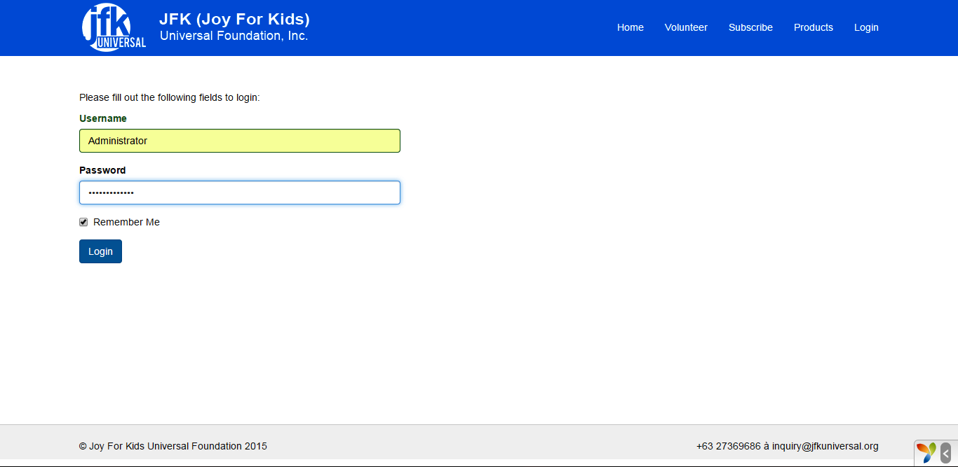

* The administrator has to login 1st before going to the homepage for security purposes.

1. **MAIN PAGE**

2.1 Main Page

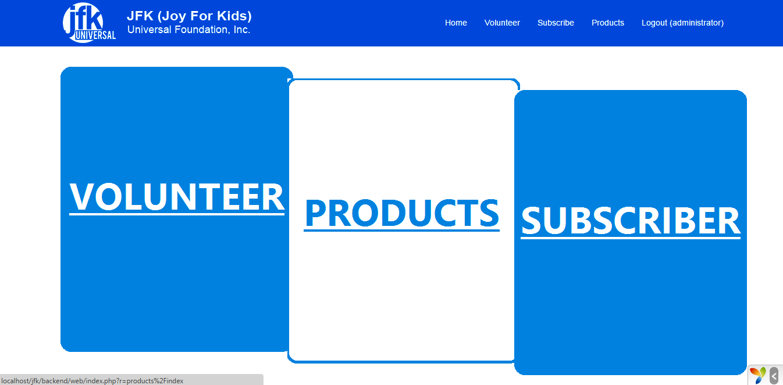

* This is the home page for the admin side which shows the 3 main modules of our system.

1. **VOLUNTEER PAGE**

3.1 Volunteer Page

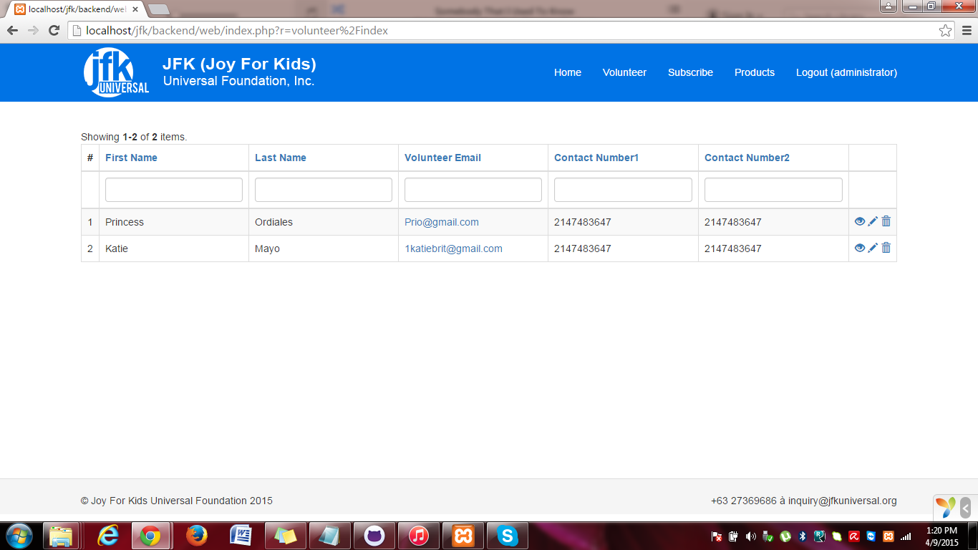

* This page shows the people who have volunteered in the front end with their details as well o be able to send then the latest events for them to join.

1. **SUBSCRIBER PAGE**

4.1 Subscriber Page

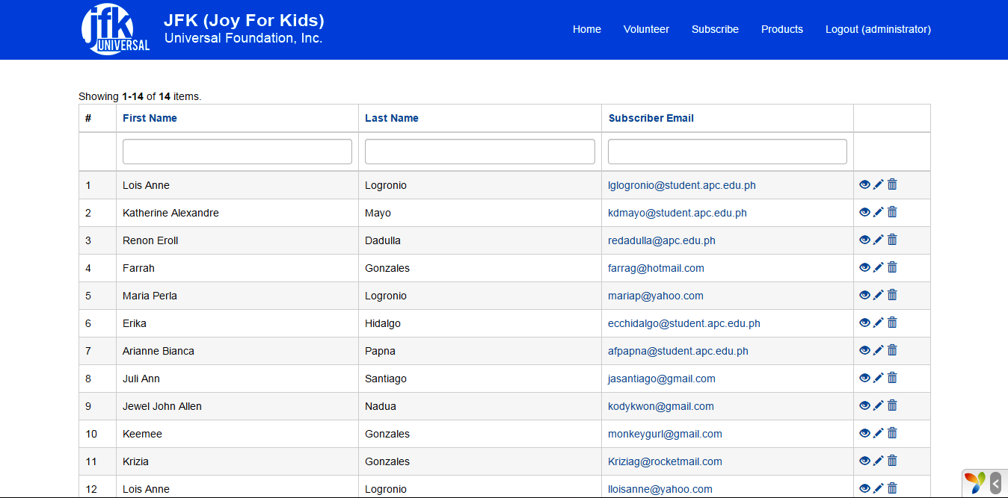

* This shows the clients and the customers who have subscribed which has their first name and last name and their email provided to address them properly.